Atypical Hematuric Presentation of Yolk Sac Tumour
Karthik K¹, Azam, Am Basheer

¹ Department of Surgery, School of Medical Science, Universiti Sains Malaysia, 16150 Kubang Kerian, Kelantan, Malaysia
² Department of Urology, Hospital Raja Perempuan Zainab II, Kota Bharu, Kelantan

Abstract
Testicular cancer, a rare entity encompasses about 1% of male neoplasms and 5% of urological tumours. It’s prevalence has been increasing in the last decade, particularly in industrialised nations. These tumours can be divided as either Germ Cell Tumours and Non Germ Cell Tumours and histologically, 90-95% of the diagnosed cases involves germ cell tumours. Yolk sac tumours are a rare type of Non Seminomatous Germ Cell Tumour that is derived of cells that resemble the yolk sac, allantois and extraembryonic mesenchyme. Typically, they can be seen in Males and Females, involving the testis, ovary and other sites such as mediastinum. Herein we report a case of a young man who presented with polypoidal bladder tumour with prostatic involvement clinically thought to be bladder carcinoma. However, the corresponding histopathological examination revealed a yolk sac tumour.

Key words: Yolk Sac Tumour, Hematuria, Atypical

Introduction
Testicular cancer, a rare entity encompasses about 1% of male neoplasms and 5% of urological tumours. It’s prevalence has been increasing in the last decade, particularly in industrialised nations. These tumours can be divided as either Germ Cell Tumours and Non Germ Cell Tumours and histologically, 90-95% of the diagnosed cases involves germ cell tumours. Yolk sac tumours are a rare type of Non Seminomatous Germ Cell Tumour that is derived of cells that resemble the yolk sac, allantois and extraembryonic mesenchyme. Typically, they can be seen in Males and Females, involving the testis, ovary and other sites such as mediastinum. Herein we report a case of a young man who presented with polypoidal bladder tumour with prostatic involvement clinically thought to be bladder carcinoma. However, the corresponding histopathological examination revealed a yolk sac tumour.
Case Report
A 36 year old gentleman, previously known to be well, presented with intermittent non radiating right loin pain, dysuria, and hematuria for about a month’s duration. He sought medical assistance when he developed frank hematuria, abdominal distension and difficulty to pass urine.
Clinical examination at that time revealed a soft abdomen, with a vague mass palpable over the suprapubic region and bilateral atrophic testes were vaguely palpable in the scrotal sac. Otherwise, there were no palpable lymphadenopathy or other significant findings. His blood investigation revealed renal impairement, with a Urea of 19, Creatinine of 995 and Hyperkalaemia.
An abdominal ultrasound was performed which revealed bilateral renal parenchymal disease and mild hydronephrosis. A lobulated urinary bladder mass over the base measuring 7.4 x 5.3 x 5.5 cm (AP x W x CC) with no obvious colour flow on doppler that could arise from either the bladder or prostate. Both testes appeared heterogenous, with right testes measuring 0.9 x 1.6 x 2.5 cm (AP x W x CC) and left testes measuring 1.1 x 1.5 x 2.3 cm (AP x W x CC). Both testes had a foci of small calcifications with an ill defined hypoechoic area which may represent post-infective changes.
Thereafter he was subjected to a cystoscopic examination under local anaesthesia., which revealed a tumour inside the prosthetic urethra, with bleeding from a raw area. Visualization was difficult due to the blood clots, and the patient was unable to tolerate the evacuation process.
Subsequently, we proceeded with Trans Urethral Resection of Bladder Tumour under General Anaesthesia. The intraoperative findings were a papillary growth over the entire trigone extending to the prostatic urethra up to the verumontanum. The tumour was resected until the base, however, it looked infiltrative, around 3-5cm. The unaffected bladder mucosa was normal, however both ureteric orifices were not visualized even after tumour resection. The tumour specimen was then sent for Histopathological Examination.
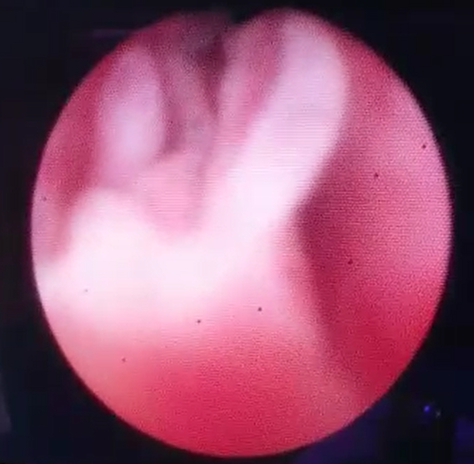
Figure 1 Papillary growth over prostatic Urethra extending to verumontanum
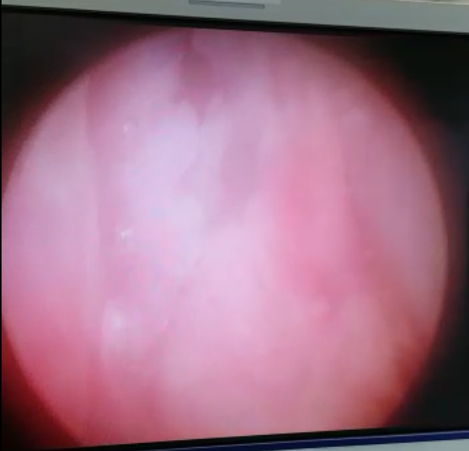
Figure 2 Papillary growth projection over the entire trigone.

The histopathological examination revealed multiple fragments of malignant cells arranged in sheets, alveolar and microcystic pattern. The cells are polygonal with distinct cellular membranes. Surprisingly, there were prominent tumour cells surrounding blood vessels forming Schiller-Duval Bodies, which are pathognomonic for yolk sac tumours.
Figure 3 Schiller-Duval Bodies

The specimen was tested with multiple immunohistochemical staining.
AFP, CKAE1 AE3 – Positive
CD117 – Focally Positive
CK7, Beta-HCG, PAX-8, EMA, CK20, CD 30 - Negative

The sampling done over the prostatic region showed fibromuscular tissue infiltrated by malignant cells arranged in clusters and trabeculae. No Schiller-Duval bodies were visualized within the prostatic sampling.

Figure 4 Prostatic Sampling

Given the findings, the pathologist described the possibility of germ cell tumour with pure yolk sac component as well as mixed germ cell tumour. Furthermore, a primary yolk sac tumour of the bladder could also be a possibility.

Whilst awaiting the histopathological report, the patient underwent CT Scanning of his Thorax, Abdomen and Pelvis.
In the abdomen, a heterogenous enhancing mass was visualized at the bladder base with prostate involvement. A normal prostate gland was not visualized. The entire bulk of the mass measures 6.9 x 6.6 x 6.9cm (W x AP x CC). Seminal vesicles could not be visualized. The mass is in close proximity to the right ureteric orifice, however it is patent. The left distal ureter was involved with the mass and the ureteric orifice was obliterated. Posteriorly, the mass indents on the lower rectum wall with no clear fat plane. There is presence of multiple hypodense lesions in segment V, VI, and VII of the liver, the largest over segment V measuring 2.1 x 2.0cm. Multiple enlarged matted para-aortic, paracaval, and iliac nodes with central necrosis within, largest measuring 4.4 x 4.1cm. There was also a suspicious lytic lesion at the body of L4 Vertebra.
In the thorax, there were multiple lung nodules scattered over the bilateral lungs. The largest of these nodules were noted in the superior segment of the right lower lobe, measuring 1.2 x 2.3 x 2.5cm (AP x W x CC)
The CT imaging revealed a Bladder Tumour with local infiltration and nodal, liver, lung metastasis and a suspicious L4 Vertebra involvement.
Figure 5 CT Scan Images
With these findings, he was subsequently referred to the oncology team for initiation of chemotherapy.

Conclusion
Testicular cancers amounts to a small number of cases in the population. Within that, a yolk sac tumour is even more rare. We would like to highlight the highly unusual presentation of a yolk sac tumour in a young man with hematuria as the primary symptom which acts as a subterfuge in the initial diagnosis as the management for a yolk sac tumour and a bladder tumour varies significantly. It would be prudent to consider proper history taking, and clinical acumen in order suspect the possibility of a germ cell tumour in the advent of a non-palpable, or vaguely palpable atrophic testes in a man at his third decade of life.

References:
1. Barman, D.C., et al., Yolk sac tumour of the cryptorchid testis, with an unusual presentation - diagnosed by fine needle aspiration cytology. J Clin Diagn Res, 2013. 7(7): p. 1444-6.
2. Ho, C.C., et al., Yolk sac tumour. Report of 2 cases and review of the literature. Taiwan Yi Xue Hui Za Zhi, 1980. 79(12): p. 1163-72.
3. Janugade, H., J. Monteiro, and S. Gouda, Pure yolk sac tumour, post-pubertal type, arising from cryptorchid testes. BMJ Case Rep, 2019. 12(7).
4. Mui, W.H., et al., Primary yolk sac tumour of the urinary bladder: A case report and review of the literature. Oncol Lett, 2014. 7(1): p. 199-202.
5. Muley, P.R., et al., Yolk sac tumour of testis (A report of 7 cases and review of literature). Indian J Pathol Microbiol, 1982. 25(1): p. 81-4.
6. Tseng, M.J. and S.M. Jung, Primary extra-gonadal yolk-sac tumour of pelvis with unusual presentation. Lancet Oncol, 2007. 8(2): p. 179-80.

