PART 2 MMED SURGERY
BATCH 2018/19
Summarized Guide of Part 2 Exam and Questions from Essay, Clinicals and Viva from May 2022 Exam (UM)

Compiled By: Karthik Krishnan
Contribution by MMed Surgery Batch 2018/19
Essay Compilation Contribution by UM Batch

e
Format

The part 2 exam is divided into 3 components: Theory, Clinical, Viva Voce.
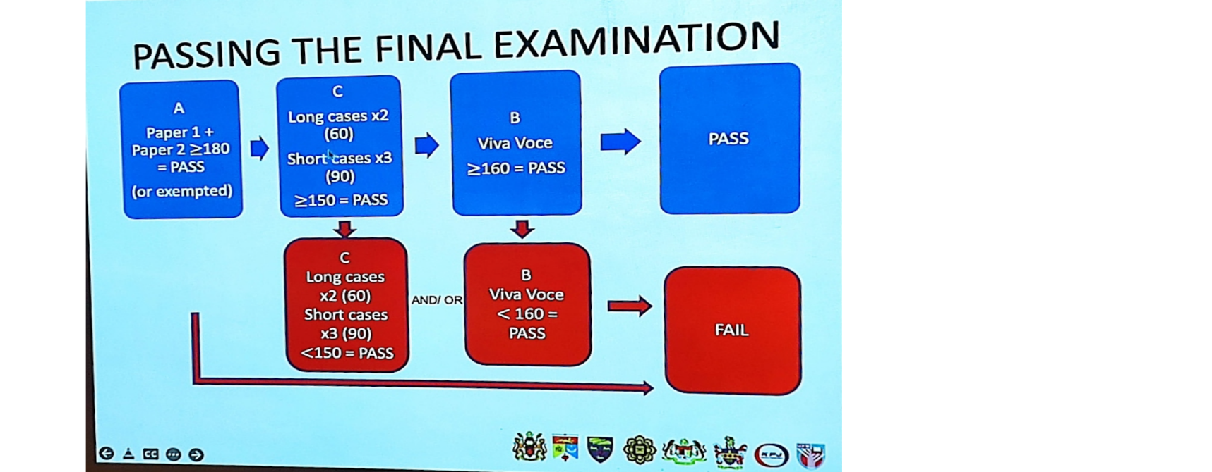

The Candidate will need to first pass the Theory component in order to be eligible to proceed for the second and third component. The minimum mark to pass each component is 50%, and the marking scheme will be explained later. If you need to resit for the exam for a 4th attempt, then you will need to resit for the Theory paper once again. Each component must be passed in order to be successful in the exam. As the Part II exam is an intercollegiate exam, the exam centres rotate and this exam was held in Universiti Malaya.

THEORY
- The theory component is an essay format examination.

- The exam is divided into two consecutive days.

- There is often a 3-week gap between the theory paper and the second and third component for the Part 2 exam.

- A combined minimum of 180 marks in total is required in order to pass the theory component. Marks are combined from both papers together.

- Both papers has a total of 180 marks (360 combined). It consists of 2 long essays (40 marks each) and 5 short essays (20 marks each)

- The session is from 9 am to 12 pm. Time management is important in order to be able to answer all questions.

- As no additional marks will be given beyond what is stated next to the question, it is advised to spend a time equal to the amount of marks as a rough gauge in answering the question (i.e. 6 marks = 6 minutes)

- Results will be announced on the third day after marking is completed.

- Images and questions stated in this compilation are not verbatim. They are based on recall, as well as image acquired from external sources.

Compilation of Essay questions are courtesy from the Corresponding UM Batch
Paper 1

- A 45 year old lady came to your clinic with breast swelling.
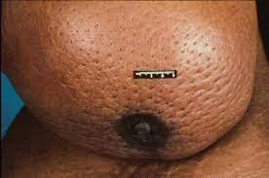
(Picture of bilateral breast, right breast swollen, axilla seen, no obvious LN)
  - Comment on the breast swelling and the likely diagnosis (6 marks)
  - What are the imaging modalities that you would use to workup for this patient (8 marks)
  - What are the methods in acquiring a tissue sample that can be done with justifications and disadvantages (6 marks)
  - What are the treatment modalities that you would impart for this patient (20 marks)

- 45 year old man was stabbed twice in the left lower back. He does not know the length of the weapon used. On admission, he was breathless. His vital signs were RR 20/min, BP 135/75mmHg, HR 120bpm

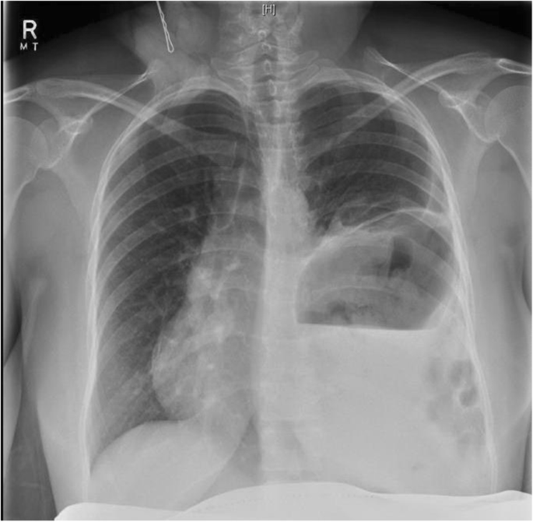
  - Comment on the X-Ray (4 marks)
  - What is the likely diagnosis of this patient (2 marks)
  - What are the initial measures you would like to perform for this patient (8 marks)
  - What are the other possible injuries that this man may have sustained (8 marks)

The patient remained stable on observation
  - What is the next imaging modality of choice you would like to perform. What do you expect to see in the findings (8 marks)
  - What is the definitive treatment for this condition (10 marks)

- A patient was referred to you for an arteriovenous fistula that is “impending rupture” from a dialysis centre
  - What are the symptoms you would look for that tells you that this is an “impending rupture”? (6 marks)
  - What investigations would you like to do to determine your diagnosis (4 marks)
  - How would manage this patient (5 marks)

During review, the patient’s aneurysm ruptured. Hypotension, tachycardia

  - Now how would you manage this patient (5 marks)

- 70 year old man came with abdominal pain and an irreducible 10cm x 10cm left inguinal hernia. He appears to be tachycardic at 120bpm and was told to have chronic AF on daily warfarin 2mg
  - What is your initial plan of treatment for this patient (6 marks)
  - What further history would you like to acquire from this patient to help you decide on the intended management (6 marks)
  - What are the risk factors with regards that has to be taken into consideration with justifications to the answer (8 marks)

- A hepatitis B alcoholic patient was brought into the emergency department diagnosed to have esophageal varices
  - What are your initial plans of treatment for this patient (6 marks)
  - What are the endoscopic modalities that you can use for hemostasis (4 marks)
  - What is the long term management for this patient (5 marks)

He subsequently had rebleeding in the ward

  - Explain the measures that can be taken (including medical treatment) that can be used to address this issue (5 marks)

- 60 year old man, no family history. Presented with frequency and dysuria. Serum PSA was 12.
  - What is PSA and the causes of a raised PSA (6 marks)
  - What are the management options available for this patient (6 marks)
  - What is the likelihood that this patient may have prosthetic cancer (2 marks)

This patient was found to have locally limiting prosthetic cancer

  - What is the treatment modalities for this patient (6 marks)

7.
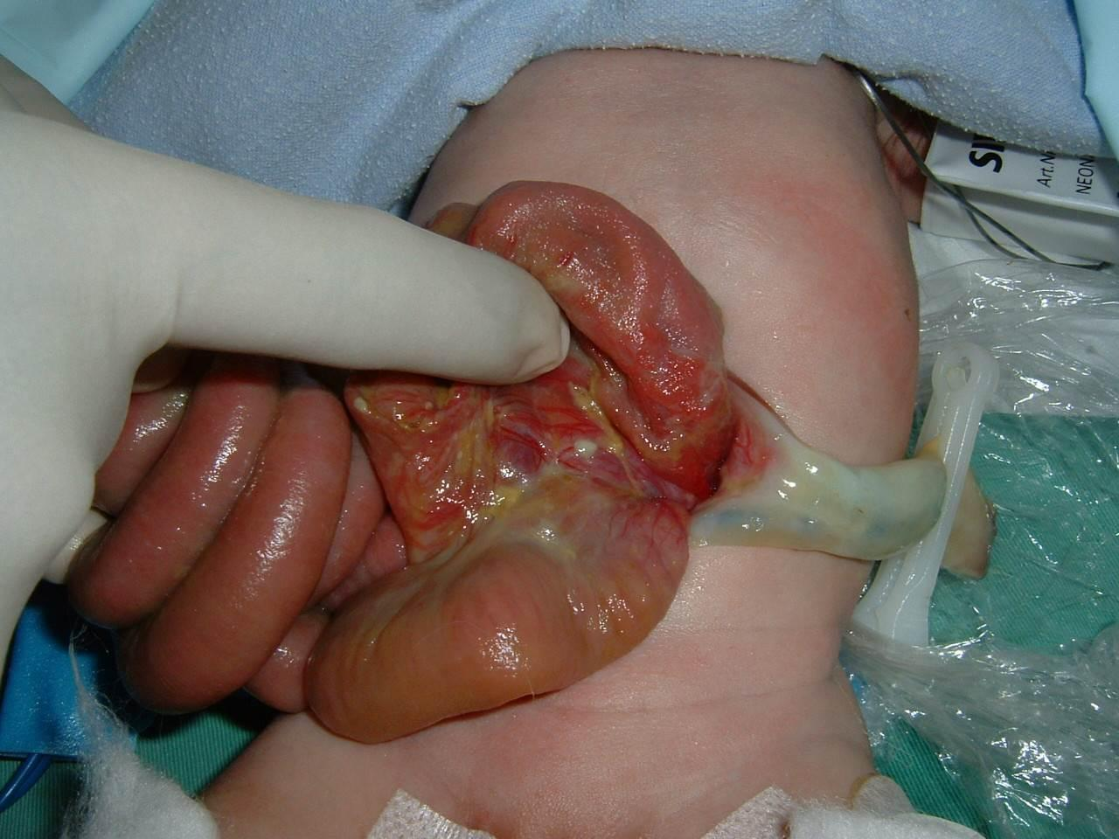
The picture above shows a neonate delivered 15 minutes ago, at full term by spontaneous vaginal delivery. The APGAR score at 1 and 5 minutes were 8 and 9 respectively.

a) Give your diagnosis with reasons. List one likely differential diagnosis. (6 marks)
b) Briefly discuss the immediate management of this neonate. (9 marks)
c) List the options in definitive management. (2 marks)
d) List three post-operative sequelae/complications that may commonly occur within the first two weeks of definitive management. (3 marks)

Paper 2

- 23 year old lady was admitted for jaundice. She has had a laparoscopic cholecystectomy FOUR days prior and was told to be uneventful.
  - List the possible causes for this condition (6 marks)
  - How would you investigate and manage this patient (34 marks)

- List the non-medical treatment for haemorrhoids, their indication with a brief description, advantages and disadvantages. (40 marks)
You may or may not choose to tabulated your answers as below
 | Procedure | Indication | Advantages | Disadvantages
1
2
3
..
..

- A 6 week old child has just completed a 4 hour abdominal surgery for the correction of a congenital defect. You realise the orthoban of the lower limbs was damped and the branulla on the dorsum of the foot dislodged.

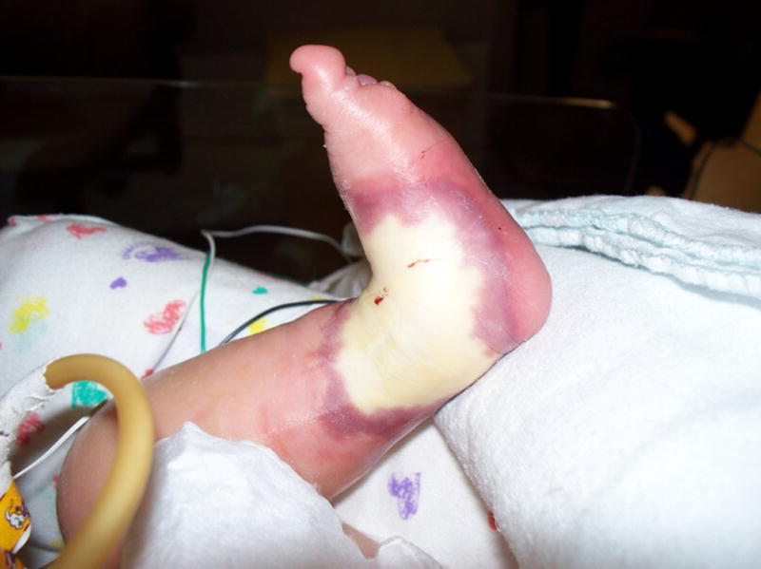

- Describe the picture (4 marks)
- What are the further management you would do for this patient
  - Clinical management (6 marks)
  - Administrative steps (6 marks)
- Enumerate the subsequent sequalae and complications for this condition (4 marks)

- 70 year old man presented with abdominal pain and vomiting to the emergency department of a District Hospital. A CT Scan was done diagnosing an abdominal aortic aneurysm and was referred to your centre
  - What other information you would like to find out from the referring doctor prior to transfer? (6 marks)
  - What are the important preparations you would like to confirm with the referring in order to ensure a safe transfer? (6 marks)
  - While waiting for the patient, what are the preparations you would like to make in your centre? (4 marks)

The patient arrived in the emergency department, BP 60/40mmHg, HR 120bpm. Patient was intubated and resuscitative efforts was made.
After 30 minutes, the pupils are fixed dilated, SBP 60mmHg
  - What is your subsequent management plan. (4 marks)

- A 60 year old man complained of melanic stools. Colonoscopy was done that found a polyp 25cm from anal verge
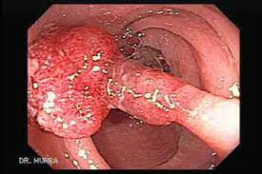
  - Describe the image (2 marks)
  - What is the different endoscopic features between a malignant and a benign colonic polyp (4 marks)
A polypectomy was done and the histopathology confirmed colon cancer with margins involved
  - What are the features in this polyp that may indicate lymph node metastasis (4 marks)
A surgery was done, intraoperatively the lesion could not be found
  - What measures would you take for the surgery (4 marks)
  - What preventive measures can be done to prevent such an incident from occurring (6 marks)

- A patient came to you with an anterior neck swelling and breathlessness. CT Scan was done
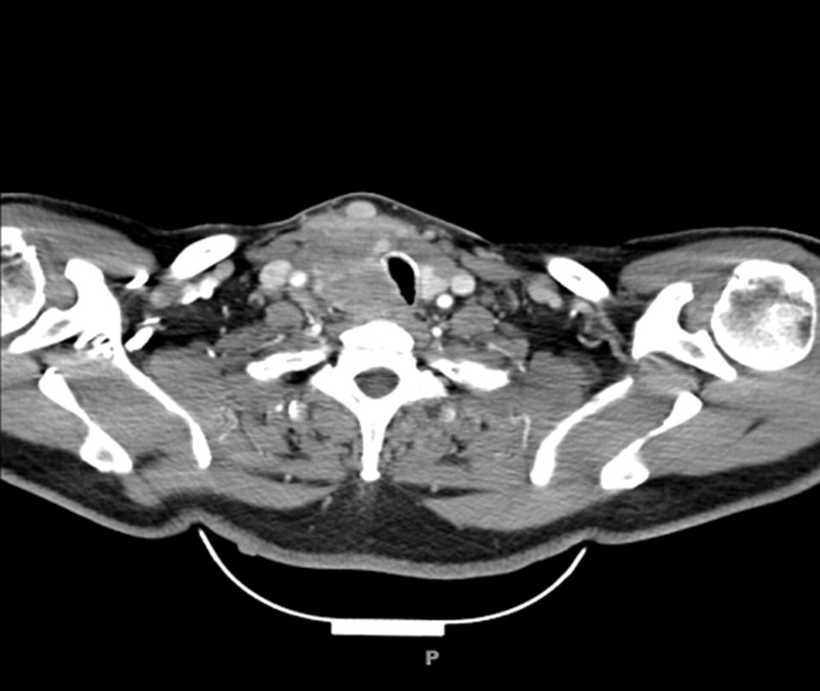

  - Describe the CT Scan (4 marks)
  - What are the symptoms associated with this lesion that you would look out for (4 marks)
HPE and workup came back as a locally advanced papillary thyroid carcinoma
  - What is the principles of surgery and subsequent management that you would like to do for this patient (8 marks)
  - What is the role of radiotherapy in this patient (4marks)

- 25 year old man who had severe traumatic brain injury following a road accident. Was ventilated via volume control. Noted his ICP increased from 15mmHg to 23mmHg. CPP for this patient was 43mmHg
  - What is the formula you would use to calculate CPP and calculate the MAP for this patient (4 marks)
  - What would the potential causes be that would cause of increase in Intracerebral pressure (4 marks)
pH 7.21
pO2 32
PCO2 56
sO2 63
Partial arterial pressure 12 (high)
Partial pulmonary arterial pressure – high
Partial occlusive pulmonary arterial pressure – high

  - Interpret these results and what is the likely diagnosis (6 marks)
  - What is the likely cause of this condition (4 marks)
  - What are the corrective measures you would like to do for this results (2 marks)

CLINICAL

- The clinical component is divided into two days. One of the days consist of Short cases and the other would be for long cases.

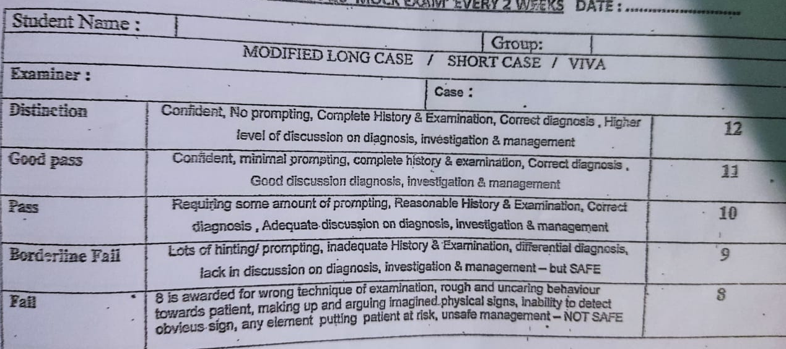
- The rough marking scheme for both clinical and viva components are depicted above.

- A minimum combined total of 150 marks is required in order to pass the clinical station. The marks are added together between the cases and only the overall marks are taken.

- Even if one of the examiners give you a borderline fail (9), it can be compensated by having acquired a 11 from another station. Essentially 10 marks are needed from all examiners for all stations in order to pass. Maximum marks from clinicals are 180 marks.

- Each candidate will be given 2 long cases and 3 short cases with 3 examiners for each session. For each long case, the candidate is allocated 30 minutes. It is up to the candidate how they wish to comfortably divide their timing allocation. Do take note, that some examiners would prefer running commentary and others would prefer you summarize at the end. This can be clarified from the leading examiner at the time of the session. The candidate is expected to acquire history, thereafter perform systematic clinical examination as well as specific examination. At the end of the examination, the candidate must be able to formulate a set of differential diagnosis. Most of the mark comes from the discussion after examination, and the more questions you are asked, the higher your chance to acquire more marks. Therefore, it is essential to allocate adequate time for each part. As an example, 10-15 minutes can be allocated to history taking, 5-7 minutes for examination and the rest for discussion.

- After you’re done examining the patient, you will be brought into a discussion room. Therefore, you will no longer be able to ask the patient anymore questions. During the discussion, you may be shown various images such as X-rays, CT Scans, Fluoroscopic images or even intraoperative / resection specimen.

- After you are done with the first long case, you will be allocated a different set of 3 examiners for the second case. This session will continue similar to the first.

- Short cases will be conducted on another day. There will be 3 short cases, and 3 examiners, with one examiner leading the questioning on one patient. 20 minutes will be allocated.

- For short case, you will be given instructions by the examiner to examine the patient. It may be general (Examine the abdomen) or specific (Examine the groin).

- Again, some examiners prefer running commentary, and others prefer a summary. You can enquire at the start which way the examiner would prefer.

- After examination, the candidate is expected to come with a list of differential diagnosis and discussion will take place from there.

- This is repeated until all 3 cases are completed.

- Time management is similar here and its advisable to leave a sizeable amount of time for the discussion as this is the portion where the candidate will be able to acquire additional marks.

LONG CASE AND SHORT CASE

Hafzan
Long Case 1) Prof See, Mr. Razali, Prof Azlan
A case of CLTI – Hx of BKA and now with TM amputation on contralateral side.

Besides description of the wound and coming with a diagnosis, lines of questioning include
- PTA 2+ clinically? How to confirm – Biphasic on Doppler
- Why check abdomen? Check for presence of any pulsatile mass
- Possible differential diagnosis – DFU
- Difference between CLTI and DFU
- CTA Given – To describe

Long Case 2) Dato Imi, Dato Fitzgerald, Mr. Faizal
Case of pancreatic Ca currently on 2nd line Gemcitabine, 5-FU and RT.
- Asked if any hepatomegaly present – not present. Do not make up signs
- Differential diagnosis – gastric ca, COJ, Pancreatic Ca
- Why not GIST? – Patient on Chemo, not Imatinib
- Ix to perform – basic blood, tumour marker, ca 19.9
- Given CT Scan – description – head of pancreas Ca, to identify and describe liver lesions, celiac trunk, sma and PV
- How to assess patient after chemo? RECIST Scoring system
- If patient jaundiced? How to manage? Review LFT – identify if Obstructive or Hepatic in nature.
- When patient needs drainage? TB >250, cholangitic, and to buy time for Surgery

Short Case 1) Mr. Faizal, and 2 other examiners Unsure
Lipoma over Right U/L

- What is slip sign? Muscle attachment, function of muscle?
- Central chest swelling, soft, sebhorrhoeic discharge – Dx Sebaceous Cyst, Desmoid Cyst
- Any other test to perform – Fluctuant test
- Treatment – Excision biopsy and Antibiotics if infected

Short Case 2) Mr. Faizal and 2 other examiners Unsure
Right inguinal hernia

- Inguinal swelling, unable to get above
- Why check scrotum / testis – differentiate hydrocoele, thickened cord – however examiner did not want the scrotum checked. Proceed with occlusion test.
- Tx – open hernioplasty, tension free mesh repair. Lichtenstein repair, as recurrence 1%.
- If have facility and patient agree, for laparoscopic surgery, refer to high volume centre.
- If you have opportunity to learn lap, which you prefer – TAPP
- Why not TEP – Technically challenging
- What structure you need to be aware during TEP? Inferior Epigastric Artery

Short Case 3) Mr. Faizal and 2 other examiners Unsure
Right breast Lump

- Nipple retracted, no discharge, breast lump 3x2cm upper outer quadrant – clinical staging T2N1Mx
- If T2N0M0, what is your max? BCS + RT
- Contraindication for BCS? Multifocal, multicentric, refuse RT, BRCA Gene
- Examiner wishes to hear if the hospital does not have RT facility, therefore should not proceed with BCS.

Hafiez
Long Case 1) Dato Jiffre, Prof Ismail, Prof Andee
60 year old man with h/o progressive dysphagia for 2/12 with post prandial vomiting. A case of COJ Adenoca with underlying MNG. On Anti-thyroid medication.

Relevant clinical examination – Malnourished patient, pale, had a silicone RT inserted. Has chemoport scar. No mass palpable.

- What is your next plan – OGDS and biopsy
2) OGDS image shown – noted stricture at distal oesophagus
3) Where should you biopsy? – At stricture site
4) Next offer imaging, CT TAP, but Prof Ismail said a PET CT was done in the centre.
5) PET Scan image given – there is uptake at distant organ such as liver – Stage IV
6) Next plan – Palliation, chemotherapy provided patient is fit, pain control, optimise nutrition. Enteral feeding if feasible, TPN Support, definite would be long term tube feeding beyond the tumour. Any other option? Answered gastrostomy.

Long Case 2) Prof Mat Salleh, Ms. Maya, Prof Yushak Abdul Wahab
Case of Complex FIA 2* Cron’s disease.
1) Diagnosis – Complex Fistula 2* Cron’s disease in relapse.
2) Mx – What blood ix to look into, for malnutrition, management for nutrition, and establish the diagnosis by colonoscopy
3) Shown a colonoscopy image – features – fissure, cobblestone appearance.
4) How to take biopsy – away from ulcer/slough
5) Next – Continue medical mx for Cron’s. Offer EAUS and MRI pelvis to delineate anatomy.
6) Asked if these modalities not available – answered CT scan – shown ct image. Noted thickened bowel, but cannot appreciate collection or fistula tract. Told that the fistula is 4cm from anal verge. Ran out of time at this point.

Short Case 1) Lead: Prof Ikhwan
Recurrent right breast cancer with possible left Fibroadenoma

- Mx – establish diagnosis by completing triple assessment.
- How to take biopsy – Wedge Biopsy
- Arrange CT TAP to see evidence of distant metastasis. Start treatment according to latest staging
- Palliative chemo if Stage IV

Short Case 2) Lead: Mr. Azim
Right BCF with CVO

- How do you palpate for thrill? Venous limb? Anastamotic site?
- What is your concern for this patient – SVC Obstruction
- How to investigate? Central Venogram
- Any simple initial IX? – US duplex assessment – look for thrombosis, stenosis, pseudoaneurysm
- Plan – Central Venogram KIV plasty / dilatation

Short Case 3) Lead : UM Prof
HCC

- What is the most common cause of hepatomegaly with ascites – HCC with PV Thrombosis, secondary liver metastasis.
- What is the difference between spider naevi and petechiae?
- What is the cause of isolated ascites – TB Gut, mucinous ovarian ca, peritoneal carcinomatosis, PV Thrombosis
- What is the classification for HCC that you know – BCLC
- What is the stage for this patient – Stage C
- Treatment – Systemic Therapy with TKI

Ram
Long Case 1) Prof Rohaizak, Prof Azmi, Mr. Rashide
Case of Left Staghorn Calculus with possible underlying Congenital PUJO
From history – recurrent renal calculi since childhood, and undergone multiple procedures. Dysuria, and cystinuria with sibblings having similar problem.

- Summarize the case
- What is the cause of recurrent stones? – Infective, obstructive or metabolic cause? Obstructive could be congenital obstruction like PUJO, but likely metabolic (cystinuria)
- How to ix further – RP, WC (to see infection), Urine analysis, Culture and CTU
- CT Images shown – large staghorn calculus occupying left PC system, good cortical thickness B/L kidney, contralateral kidney no stones.
- How to assess the kidney is functional – good cortical thickness, renal profile. Objectively DTPA to see split renal function
- What procedure do you think this patient underwent – Nephrolithotomy, but answered nephroureterotomy.
- Are these procedures still done? No, now PCNL.

Long Case 2) Prof Zaidi, Prof Ong, Mr. Chew
A case of Conn’s adenoma.
From history – hypertension, bad headache and told to have low salt. Symptoms of pheochromocytoma, and Cushings were also asked.
Examination was unremarkable, forgot to check thyroid mass (MTC with Pheochromocytoma)

- Summarize the case
- How to investigate – Serum K+ and correction, Serum aldosterone and renin ratio – was shown the ratio, consistent with Conn’s
- Other ix – free serum and urine metanephrines for pheochromocytoma
- Imaging – CECT Adrenal protocol
- Any other ix – localization test, adrenal venous sampling, if unable to localize on CT
- Other ix before surgery – they wanted to hear USG Thyroid to look for thyroid mass.
- Surgical intervention – adrenalectomy, either open or laparoscopic. Transabdominal or retroperitoneal approach.

Short case 1) Lead: Mdm Tuan Nor
Left inguinoscrotal hernia with swelling over right hernia repair scar.

- Diagnosis – Left indirect inguinal hernia. Right side – unable to illustrate recurrence
- Complete examination – further history, risk factors, fitness for surgery with abdominal examination and DRE
- How to ix the right side to confirm diagnosis – USG
- What next? – Optimize risk factors, put up for surgery. Laparascopic approach, since recurrent and bilateral.
- TAPP vs TEP – the recurrent rates for both. Mesh types for TAPP and TEP – what’s the difference.

Short Case 2) Lead: Mr. Rosnelifaizur
Left lower limb venous ulcer with left groin scar. Did a doppler test to assess arterial system.

- Diagnosis – Healing ulcer over left leg gaiter area, previous scar likely HSVL. No evidence of stripping or stab avulsion
- Mx – dressing, limb elevation, avoid standing long hours
- Further ix – Usg dopppler to assess deep system. Assess perforator system

Short Case 3) Lead: Prof Sharun Niza
Post left mastectomy with local recurrence in axilla.

- MX – full history of previous cancer, chemotherapy and adjuvant therapy if given, previous staging
- Now need to restage- CT, need MMG and USG of contralateral breast + USG of axillary node with biopsy
- If local recurrence – if amenable for resection, then excise. If not then for Chemo + RT
- If systemic recurrence – chemotherapy if visceral crisis. Endocrine therapy + targeted therapy (CDK4/6 inhibitors, mTOR inhibitors with AI)

Karthik
Long Case 1) Prof Hanafiah, Dr. Suniza, Prof Junaidi
An elderly gentlemen with dysphagia and loss of weight. Gives history of endoscopic procedure done several years ago. However past 3 months symptoms have reoccurred.

- During examination, only positive finding is nutritional status. There aren’t any other findings demonstrable. The examiner asked what are the signs I’m eliciting, (guttering, thenar/hypothenar loss, temporal wasting, tricep fold etc) as nutritional assessment.
- Summary – and diagnosis. Given the age group, I told them that I have oesophageal cancer on the back of my mind, but the history is suggestive of recurrent achalasia.
- How would you like to proceed? I would like to start with OGDS. It will allow me to differentiate between CA and Achalasia – How? If Achalasia, the Scope can pass through, ca, tumour, stricture, there may be difficulty
- Anything else? I would like to do a timed barium oesophagogram. Why Barium? Why not gastrograffin – I need the weight from barium in order to open up the distal Oesophageal sphincter.
- Shown an image of oesophagogram – Bird beak appearance – suggestive of achalasia. Why is this not apple core sign – typically for colon.
- CT Scan shown – ryles tube within, thickened distal oesophageal region, lots of fluid in the oesophagus.
- What next? I need to classify based on Chicago classification – type I, II, III with a manometry.
- Treatment – Pharmaceutical – but has fallen out of favour. Endoscopic or Surgical
- In this patient, who had POEM done before, what would you do? I would redo POEM because POEM is a repeatable procedure, at least 3x. at a different angle of the wall. Dilatation at this time is not recommended as can cause perforation.
- How is POEM Done – endoscopic dissection explained – incise mucosa -> submucosal plane and scope entered via the plane 6cm proximal and 3 cm distal to junction. Myotomy of circular muscle done.
- Any other way? Botox injection, however it will reoccur in 6 months.
- Surgical option – Hellers Myotomy with a Dor 180 Anterior Wrap Fundoplication as 100% of patients post Hellers will have reflux.
- I will use Eckardt score post intervention to assess outcome

Long Case 2) Prof Nik Ritza, Prof Balan, Dato Seri Yusof
Young 35 year old gent, with a transverse abdominal scar. Complained about bilateral intermittent lower limb pain. Went to several hospitals, initially treated by physician as nerve pain. Even had MRI done and treated as nerve pain. Finally went to a surgeon, noted expansile pulsatile mass, CT done, AAA. After surgery no more leg pain, however complains about difficulty with coitus. In terms of examination, transverse abdominal scar, otherwise pulses 2+ entirely, no other significant finding. I wanted to complete examination by listening to CVS, they just asked what I wanted to find out, and didn’t have to perform it. Carotid Bruit and Cardiac murmurs.

- Diagnosis – Acute Limb Ischaemia with Abdominal Aortic Aneurysm post repair.
- Why was patient having limb pain? Possible showering of thrombus from the mural thrombus
- Why do you think this AAA was not detected by the first few doctors? Told them if I was to speculate, maybe they did not palpate the abdomen to have a raised index of suspicion
- What would you like to do? – CT scan. Shown a CT Scan, it is a Infrarenal AAA with no evidence of leak or dissection but a large mural thrombus. The AAA extends down to the illiacs.
- How would you repair AAA? – Open technique. EVAR.
- Why do you think EVAR not done for this patient? – Patient is young, life expectancy reasons. Other reasons? Patient is unable to come for frequent follow up for EVAR, and/or if patient cannot afford the EVAR stents.
- Looking at the CT Scan anything you would prepare before surgery? I will prepare the Aortic graft, bifurcated one particularly. Otherwise Aortic clamps, debakey clamps
- Why do you think transverse incision done? – Single dermatome, good pain control. Lower risk of herniation.
- Patient complained about problems with coitus, why? – During securing the lumbar vessels, it involves applying figure of 8 sutures. There is a small chance of the sacral plexus being involved which may cause the problems.
- Which system is his problem? Parasymphathetic – Erective Dysfunction
- How will you manage? Psychosocial counselling, Urology referral, and prescribing Sildenafil
- Asked about EVAR and Endoleak types. Suitability for EVAR, bifurcated grafts then bell rang.

Short Case 1 (Lead: Prof Khong Tak Loon)
A case of a well built gentleman with a mass over the Right Lumbar region 10x10cm. Told to examine the abdomen.

Running Commentary. Describe mass, is it subcutaneous, intraabdominal retroperitoneal. Examination done to identify – slip test, rectus contraction, balotability, percussion etc.
-Differential diagnosis – Lymphoma, TB Gut, Colonic Tumour, GIST. Malignancy unlikely as patient is relatively well built despite having a large lesion.
- Ix – Non Specific – Bloods, Tumour Markers. Specific – CT Scan, Colonoscopy
- Colonoscopy Normal – Blood Ix non-conclusive. Ct scan – unable to delineate mass origin. How to proceed? Diagnostic Laparascopy and biopsy.

Short Case 2 (Lead: Ms. Maya)
A case of Neck swelling. Told to examine the neck.

-Neck swelling, large goitre over right side.
-Differential diagnosis. MNG, STN
-ix – USG, Thyroid function and FNAC.
-Came back as PTC. Management
-Total Thyroidectomy. Do all PTC need Total thyroidectomy – Micro PTC and unifocal <1cm which can be treated with lobectomy
-neck dissection, types? Therapeutic, Prophylactic, which levels, how to decide?

Short Case 3 (Lead: Prof Islah)
Told to examine the abdomen carefully. Noticed a groin incision on the left side. Asked the patient to cough and there was a right groin swelling. Asked examiner I’d like to focus on the groin and was allowed to do so. A case of left open hernioplasty with an indirect hernia on the right side. I was unable to elicit recurrence even with patient standing, but during questioning I’m told it’s a recurrent hernia. After patient reduced hernia, I performed occlusion test but the hernia reoccurred. Then I asked the patient to reduce the hernia and once he was done I pushed it back in to check its entirely in.

-Diagnosis
- Why when you did the first occlusion test the hernia came out – either the patient did not completely reduce the hernia or I occluded the wrong area. However, once I ensured the hernia was completely reduced to check the second time, the hernia did not come out, therefore it’s the former.
- Recurrence rates discussed
- How will you manage this patient – refer to centre performing laparoscopic work as this is bilateral and a recurrence as well
- What are the techniques - TAPP, TEP. Which is better for Recurrence and why? Do you explant mesh?
- How is TEP done, how is TAPP done?
- What kind of mesh you will use, and why?

Thiaga
Long Case 1 (Prof See, Mr. Razali, Prof Azlan)
Middle aged female, history of right hemicolectomy for suspected ?appendiceal carcinoma, underwent post op Surveillance until diagnosed for progression of disease detected by PET Scan. Recently underwent laparoscopic staging and biopsy for peritoneal metastasis.

- How to differentiate intraoperatively appendiceal carcinoma?
- What will you do if intraoperative suspicion for appendiceal malignancy – proceed for right hemicolectomy or simple appendicectomy?
- Different types of appendiceal Ca?
- Purpose of recent laparoscopic staging from your knowledge?
- What is CRS and importance in patient selection?
- What is criteria of HIPEC? Types of Chemo and Duration?
- Chances of recurrence after HIPEC?

Long Case 2 (Dato Imi, Dato Fitzgerald, Mr. Faizal)
Middle aged Indian man presented with intermittent L/L claudication with bluish discolouration in 2019. Underwent CTA and angioplasty. Well until 2020, as symptoms reoccur and underwent Rays amputation for 1st and 2nd toes. Pre-op he underwent angioplasty again as distal runoff below popliteal non opacified. Another angioplasty done in March 2020 due to progression of CLTI. 4th toe complicated with necrosis and done amputation. Post op complicated with SSI. Diagnosed with PE during last admission and on anticoagulant. Hx of parathyroidectomy for parathyroid adenoma in 2015. ESRF on HD. DM/HPT.

- Diagnosis?
- What’s the connection with ESRF, DM, and parathyroid adenoma for this disease?
- How to diagnose the disease?
- CTA LL – asked to identify opacified area and any other abnormalities
- What type of operation for this patient? TASC Classification
- Type of graft? Superiority? Complication of graft?
- Principle of graft bypass using native graft?
- What you understand about inflow and outflow and graft for CLTI?

Short Case 1 (Mr. Faizal, Other examiners unsure)
Lipoma over right U/L

- Demonstrate slip sign
- Muscle attachment, function of muscle
- Central chest swelling, soft, sebum discharge
Dx: Sebaceous cyst / desmoid cyst
- Fluctuant test
- Tx : Excision Biopsy / Abx

Short Case 2 (Mr. Faizal, Other examiners unsure)
Thalassemia patient

- Examine abdomen
- Causes of splenomegaly
- How to investigate this patient?
- How to prepare for Op? Vaccination and post Op Abx counselling
- What will you do if US suggestive of biliary obstruction?
- How will surgery be affected if incidental findings of GB stone in US?

Short Case 3 (Mr. Faizal, Other examiners unsure)
Right breast lump

- Nipple retracted, no discharge, breast lump 3x2cm upper outer quadrant
- clinical staging T2N1Mx
- if T2N0M0, what is your management? BCS + RT
- Will you give adjuvant chemo after neoadjuvant?
- Contraindication for BCS? Multifocal, multicentric, refuse RT, BRCA gene
- What to see in HPE?
- What complications of neoadjuvant chemo?

VIVA VOCE

- VIVA Voce is divided into several tables with 20 minutes allocation
    - Principle 1
    - Reading
    - Principle 2
    - Pathology
    - Operative

- Each table is seated by 2 examiners. In total, you will meet 8 examiners.
- The image above is the similar marking sheet that is used for the VIVA session.

- At least 160 marks must be acquired across the stations in order to pass the Viva component. Both examiners will offer separate marks for questions asked by each other. So each examiner gives 2 marks.

- Principle 1 involves questions from the principles of surgery as well as basic sciences. Scenarios may be offered and the principles of management may be asked.

- Reading station – You will be given A4 paper, stationary, and an Abstract of a selected journal. You are given time to read the abstract, as well as make notes which can be brought along to the next station.

- Principle 2 – One examiner will first take you through the paper and listen to your critique. Questions will be asked pertaining to the topic, data analysis and statistics, as well as outcome. Thereafter, the other examiner will ask a question based on principle of surgery. Again, scenarios may be offered, and principles of management may be asked.

- Pathology station – Here you may be given images to decipher, or even scenarios. The idea is to answer as many questions as possible within the 20 minutes to acquire as much marks as possible. Images include mammograms, radiographs, ct scans, fluoroscopic images, clinical images, intraoperative images, or resection specimen. Rarely, you may be given histological images, or reports in order to decipher management.

- Operative station – Here you may be given scenarios and asked on performing specific surgeries. Whilst jumping straight to surgery may be time-saving, it is advised to take a moment to speak about resuscitation, planning of surgery and indication, consent, and risks. However, if prompted you’re on table, then you may start with positioning patient, special requirements (CBD, Strap, Laparascopic set etc) and enumerate the surgical steps.

- Candidates will be asked to return back in the evening whilst marks are tabulated. Results will be announced the same evening after the exam.

VIVA
Hafzan
Principle 1 (Dato Seri Yusof, Prof Ong Teng Aik)
-Elderly male ith I/O a/w AF, AKI and metabolic acidosis with low urine output
-How do you hydrate Pt? Crystalloid – based on body weight
How do you classify dehydration? – Mild, moderate, severe

19Y/O male, MVA, right pupil dilated. How do you approach?
-ATLS Protocol, intubate to secure airway, primary survey, secondary survey.
CT Scan – possible TBI – Mx – Craniotomy/craniectomy, mannitol, antiepileptic
GCS not improving – counsel for organ donation – How to activate? National registry, HLA matching, inform transplant team, brain death test
Brain death test – criteria, test, confirmation test, pronounce.

Principle 2 (Prof Andee, Prof See)
-Start with paper discussion
- Tumour biology: Normal cell differentiated and ability to transform to malignancy
- Why is it important? Prognostication and treatment
- How to prepare obese patient for op? Preop, Intraop, Postop actions.
- How to prevent DVT? Early ambulation, stocking, heparin.

Operative (Prof Junaini / Dr. Chew Loon Guan (CoS))
-PGU: Incision, deepened with diathermy until rectus, fine linea alba, catch with artery forcep
- How to prevent bowel injury? Lift up lineal alba when doing the nick.
- Entering abdomen, find perforation
-How to find? From greater curvature and inspect anterior surface of stomach, presence of bile and food material from the defect.
- Lavage and biopsy. How to take biopsy? Use blade, take normal and ulcerated edge of tissue
- Ask anaest to push ryles tube (Discussion ended here, as examiner did not agree with RT)

-Splenectomy: Thalassemia, massive splenomegaly
Incision – Open gastrocolic, find hilum and clamp.

Pathology (Mr. Faidzal / Mdm Tuan Nor)
-Pic of bilateral lower limb, mottling skin with gangrene, Hx of AF. Dx : ALI, Tx – Embolectomy. Common cause – Embolus. Pic of emboli shown. Differentiate embolus and thrombus.
-Pic of jaundice of sclera. Dx: Liver cause. What is possible dx of liver causing jaundice? Primary / Secondary. Ix LFT, what to see – Obstructive / Hepatic Jaundice
- Pic of gangrenous large bowel – Cause? Thrombus/Emboli. Tx – resection and stoma. If patient not stable? Chop and Drop. DCS.
-Pic of MMG – Describe – spiculated lesion. MLO view, pect major muscle, LN presence. If size 3cm what would you do? BCS + AC.

Hafiez
Principle 1 (Mr. Hariz / Prof Nik Ritza)
Elderly 80 year old man with I/O, AF, borderline Bp 100/60 HR 120, AKU with metabolic acidosis and low urine output. Transition zone at sigmoid Area.

-Impression: perforated sigmoid tumour. Start fluid resuscitation based on body weight
-Cause of AF – Dilated cardiomyopathy, valvular heart disease.
-Was given blood result, K 6.0, worsening acidosis. Give lytic cocktail and plan for dialysis.
-Types of Dialysis – Sled, cvvh, PD
-Why choose SLED/CVVH – which is suitable for this case – SLED
-INR 4, how to prepare for op – Reversal by FFP and check INR
-Why need gradual reversal – prevent APO, risk of thromboembolism, stroke
-Plan for HM procedure and aim for DCS
-Role of ct scan – needed since may change course of Mx (HM vs Stoma if Stage IV)

Principle 2 (Prof Rohaizak / Prof Ikhwan)
Appraisal – What is blinded study, how is blinded?
How to manage heterogenous population – by having inclusion / exclusion criteria
How to interpret the findings from the table from full paper and compare with conclusion of the study – Stuck here as took too long reading the table and time is up.

Patient with GOO, CKD with poorly controlled DM on metformin, not suitable for MTF since patient can’t take orally and MTF causes worsening acidosis.
What types of insulin – long and short acting
Any moderate acting Insulin?
Blood ix and how to interpret FBS, HbA1C
Complication of insulin
What is the most concern for this patient – Nutrition

Operative (Ms. Maya / Dato Fitzgerald)
A case of ascending colon tumour. Ct scan done
What are signs of resectability from CT Scan
Right hemicolectomy and operative steps
In what plain you proceed when you see the gastrocolic trunk of Henle
Cont until anastomosis – Time’s up.

A case of bleeding post total thyroidectomy, patient intubated and send back to OT, patient on table. How do you approach?
Open the layers, open the platysma and strap muscles.
Where is expected incision of the strap muscle, Upper Third.
Clean the thyroid bed by adequate washing, look into slippage of tie / clips.
How to know if carotid artery not involved – venous blood would be darker and non pulsatile.
There is slippage of tie of the STA – what is your step? Clamp with mosquito forceps and tie. Do not use diathermy.
Put local haemostat agent – Surgicel
Put drain, close the wound by layers.

Pathology (Prof Ismail Mohd Ali, Prof Zaidi)
Picture of perforated large gastric ulcer – Benign / Malignant? Plan – modified graham patch
Carbuncle of neck – Antibiotic of choice?
Unilateral gynaecomastia in male – How to investigate?
Pagets disease – How to take biopsy – What operation – Central WLE if localised to subareolar region. Mastectomy if diffuse dx/extensive DCIS
Image of ERCP with large CBD stone and dilated IHD
Plan – For Open CBDE or spyglass
External Haemorrhoid – Op? Open Haemorroidectomy
High inguinal Orchidectomy – How to investigate – What testicular tumour sensitive to Chemotheraphy?
Meckels Diverticulum – segmental bowel resection, why not wedge resection? Presence of tissue at the base of Meckel, leaving pathological tissue behind.

Ram
Principle 1 (Prof Shahrun / Prof Yushak)
Same baseline question as everyone
Prof Shahrun asked about immediate management
Prof Yushak was asking what kind of surgery, post-operative management and monitoring, post operative issues.

Principle 2 (Prof Khong Tak Loon / Mr. Mat Salleh)
Journal Appraisal
Principles of managing Nutrition

Operative (Mr. Islah / Mr. Azim)
Mr Islah – Inguinal orchidectomy and Circumcision. Unable to deliver testes – what to do? Circumcision step by step and how to overcome the difficulties.
Mr. Azim – Meckel’s diverticulectomy and AAA Exposure. Segmental resection or wedge? Also asked principles of small bowel anastomosis.

Pathology (Ms Wan Zainira / Prof Ng KL)
-Ulcerative Colitis
-Anal or anorectal carcinoma
-Testicular torsion
- Achalasia Cardia
- Low rectal carcinoma

Karthik
Principle 1 (Prof Yoong Boon Koon / Mr. Mokhzani)
Similar scenario 80/M with obstructed left sided tumour with AF and metabolic acidosis on ABG
-Discussion went along the line of resuscitation, correction of coagulopathy, dialysis, and operative management principles

-Given a case of burn from explosion. Resuscitation, Parkland, Inhalation Injuries, Risks to watch out for. Signs of inhalation injury, circumferential burns. Then this was followed by managing the patient through burn unit care. Dressings, the multiple types, and benefits. Then the discussion went to grafting. Donor site, recipient site, when to do, and the healing process (basically discussing the phases of wound healing).

Principle 2 (Prof Azlan / Mr. Salahudin)
-Journal discussion. RCT, primary and secondary objectives. Statistical significance. RCT, wanting to look at Consort checklist. Statistical analysis, graph that I wish to see and table I wish to see. Pretty straight forward discussion as you lead the examiner to showing you the full paper analysis table.

-Given a case of Rectosigmoid Ca and discussion on the principle of management. Post operatively told to have complication of bleeding, drain large amounts. Told I will inform consultant and re-explore. Told to be bleeding from raw area. So I discussed principles of haemostasis. Points anaest can do, and what surgeons can do. Talked about the various haemostatic agent. Given scenario bleeding did not stop, what to do, consultant not available. Told him I will pack and revisit with consultant. So revisit 24 hours later after packing for removal. Still having bleeding from raw area. What to do – gave internal iliac artery ligation. Discussed complications shortly and times up.

Operative (Dato’ Jiffre / Prof Balan)
-Dato asked regarding lap cholecystectomy. How many I’ve performed, can I competently perform, am I safe, and can I do it without supervision. This was then followed by questions about steps and bailout procedures. Predictive factors for difficult cholecystectomy. OTC, how to perform

-Prof Balan asked regarding right hemicolectomy. Discussed preoperative, intraoperative and post operative steps. Walk through the dissection, structures to identify, structures to preserve, and how. Gastrocolic trunk of henle, significance, how to identify, how to prevent injury. Point of transection for right hemicolectomy vs extended right hemicolectomy. Leak rate discussion, closure techniques, materials used. Discussion about drains.

Pathology (Prof Sagap / Mr. Ng CH)
Started with a scenario of breast tumour. Discussion based on BCS, indications and contraindications. Then given mammogram and told to comment. Need to identify location of tumour based on CC and MLO view. Given scenario patient refuses radiotheraphy but agreeable with surgery but does not want mastectomy. How to handle – escalate to Breast and Endocrine centre.
Next question was shown a picture of NF of anterior abdominal wall. Management was discussed, then followed by a ct image. Ct shows there is a collection intraabdominally that extends to the subcutaneous plane suggestive of a perforated sigmoid colon
Next image was an infected sebaceous cyst and discussion regarding when should surgery be done, should antibiotics be given and delay surgery. How the surgery should be done. Is this a carbuncle?
Next image was a limited right hemicolectomy specimen with a grossly enlarged appendix. Differentials – Appendicular tumour, Appendicular Mucocoele etc. Is this resection adequate? No, given the size a Proper right hemicolectomy should have been performed.
Fluroscopic image of cholangiogram – dilated CBD, IHD with filling defect in CBD - Stone

