A rare manifestation of breast cancer; Carcinoma En Cuirasse

Karthik K¹, AK Siti Hafzan¹, Maya Mazuwin Y¹, Siti Rahmah M¹

¹ Department of General Surgery, Hospital Universiti Sains Malaysia




Abstract:

Breast cancer is now the most common form of cancer in Malaysia, accounting for incidence as much as 17.7% of all locally reported cases. Locally, there is noted to be an increased incidence from the age of 40-44 and a peak incidence at 55-59 years of age. Up to 43% of patients present and are diagnosed at a very late stage (3&4). We report a rare manifestation of breast cancer in a young 34 year old woman which lead to carcinoma en cuirasse.

Carcinoma En Cuirasse is a rare cutaneous metastasis of breast cancer manifested through papulonodular lesions, erysipeloid or sclerodermiform infiltration. In this case, this patient was diagnosed with invasive left breast cancer (ER / PR –ve Cerb 3+). She had completed chemotheraphy, however had refused surgical intervention. CT staging thereafter showed the disease had progressed with metastasis to the liver, bones – thoracic vertebra, left scapula, sternum sacrum, right femur and right breast. She underwent a bout of palliative chemotheraphy, however it proved to be futile. She started developing multiple skin ulceration and nodular lesions over the chest. These lesions were tender, often ooze pus and blood, for which she was prescribed regular dressing. She presented with shortness of breath, and lethargy and chest x-ray showed right sided pleural effusion. Ultrasound guided drainage was performed and a milky white substance was drained, confirming Chylothorax.

Carcinoma En Cuirasse is a possible manifestation of cancer and is rather challenging to manage. As breast cancer becomes more prevalent, it is imperative that screening programs are widely performed to diagnose breast cancer in it’s infancy to improve outcome and prevent difficult complications such as Carcinoma En Cuirasse.

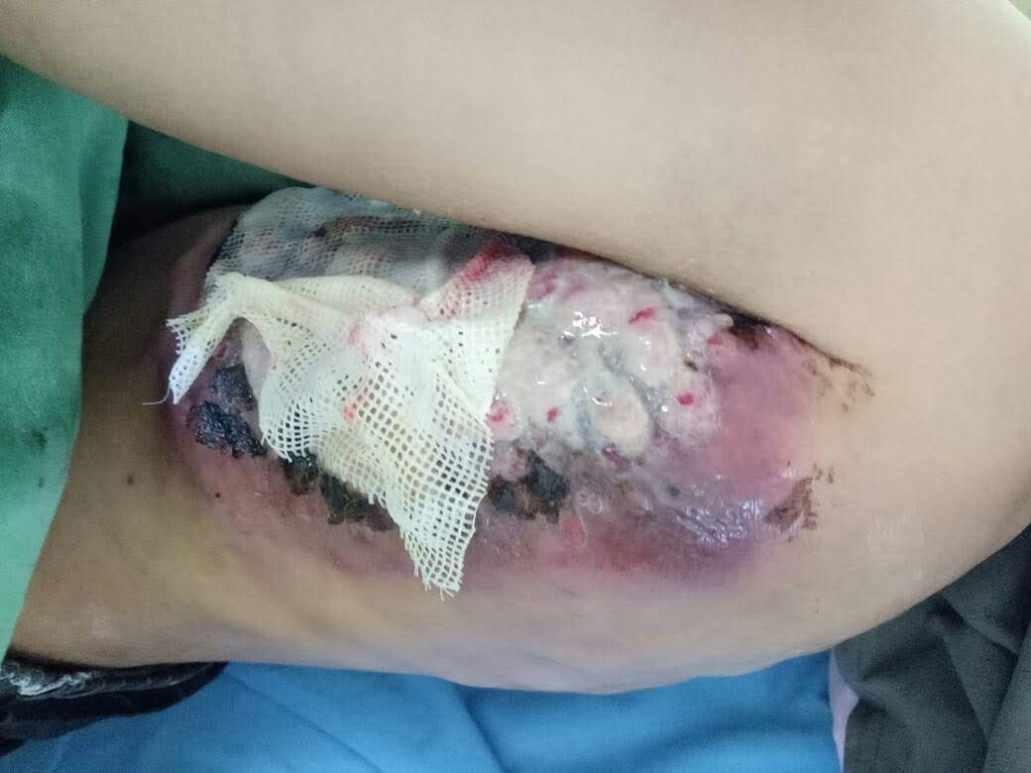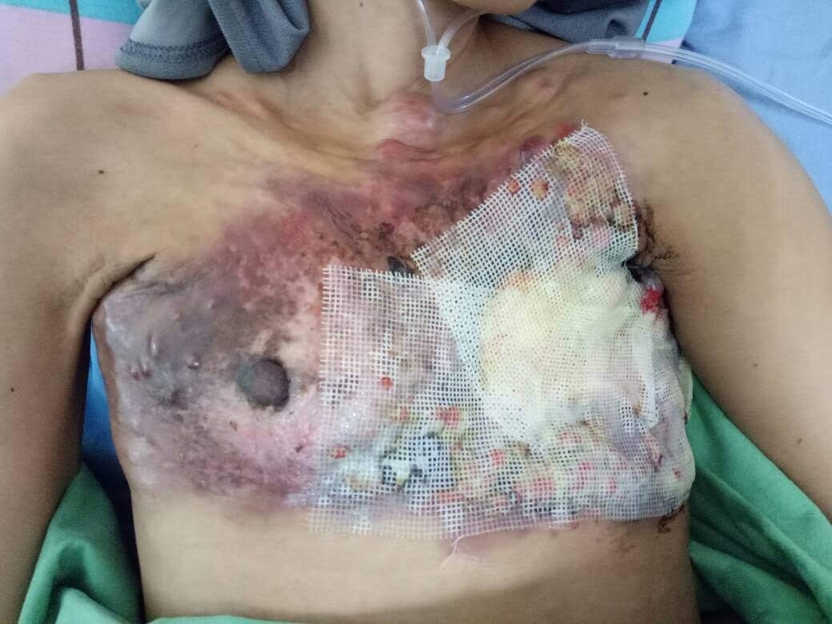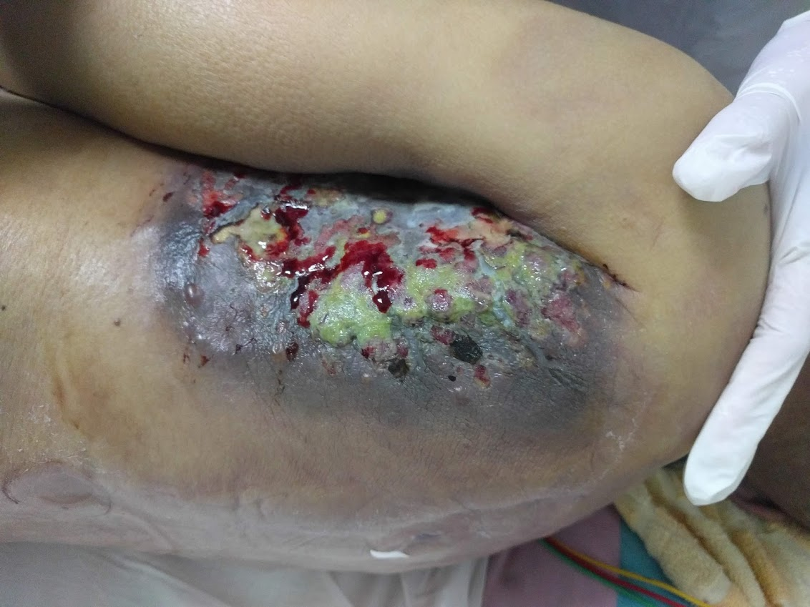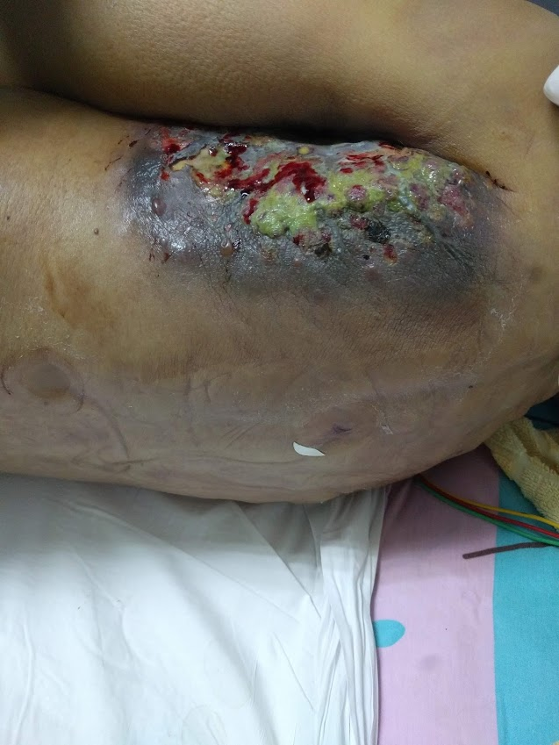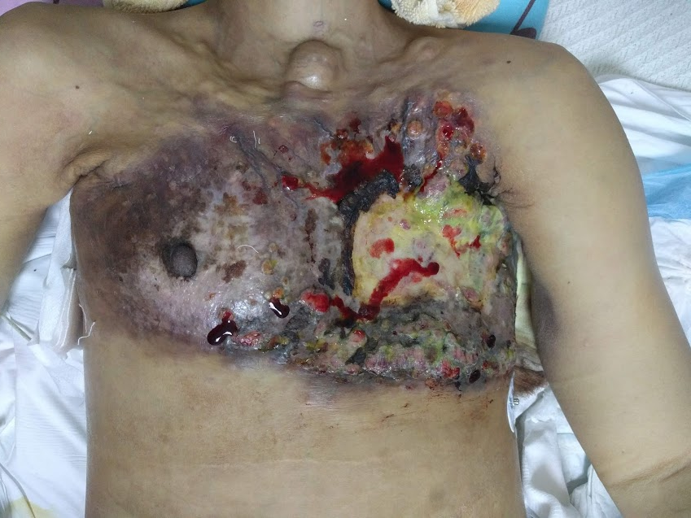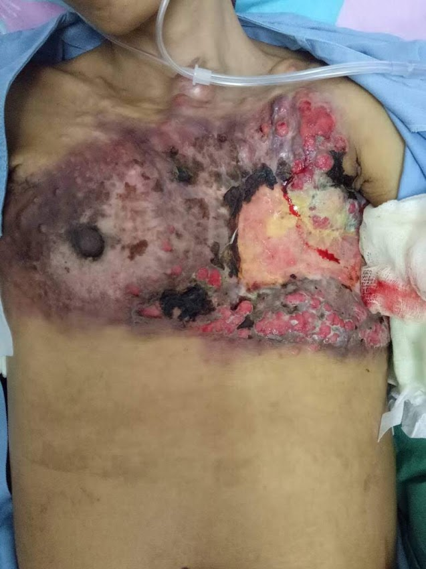

Literature Review:
- C. Mordenti, et al; Cutaneous Metastatic Breast Carcinoma: A study of 164 patients. Acta Dermatoven APA Vol 9, 2000, No 4, 143-148
- Ruben Azcune, et al; Cutaneous Metastasis of Internal Carcinomas, our experience in 94 cases. Dermatologia Argentina 2009: Special Edition – Volume XV, 44-51
- Dawson EK, Davie TM; Mammary Carcinoma With Cutaneous Carcinosis of Erysipelatodes Type. Edinburgh Medical Journal 1942 Apr; 49(4): 247-258
- Charles D. Freeman, Francis W. Lynch; Carcinoma Of The Breast With Pecular Cutaneous Metastasis; A Report of A Case. Arch Derm Syphilol. 1937;35(4):643-652
- S. Milton Chris; Inflammatory Carcinoma Of The Breast. A report of 20 cases and a review of the literature. British Journal Of Surgery Society 1950; Oct; Vol 38, Issue 150: 163-174
- Massimiliano D’Aiuto, et al; Surgery of the Chest Wall for Involvement by Breast Cancer. Thoracic Surgery Clinics 2010 Nov; Vol 20, Issue 4: 509-517
- Mohammed Kamil, et al; Cancer En Cuirasse; A Rare Primary Presentation of Breast Cancer: Report of a case. Iraqi Academic Scientific Journals 2017 Vol 16 Issue I: 112-116

